Biden should note: the Israeli government continues marching toward annexation
Shaul Arieli Haaretz, January 22, 2021

Former President Donald Trump is expected to disappear from the political arena and cease his involvement in the Israeli-Palestinian conflict. However, the Netanyahu government is riding the waves of the "Vision of Peace" plan Trump presented earlier this year, and continues to advance and implement its vision - to apply Israeli sovereignty to Area C. Despite the wave of "normalization" that is sweeping Israel and the postponement of annexation, it seems that until the Biden administration dares to present a practical plan that expresses the new president's statement of support for a two-state solution, or at least reveals "teeth" in the face of the Israeli annexation plan, Israel will continue taking steps toward implementing its vision of annexation.

The Netanyahu government is promoting the creation of conditions for the annexation of Area C, in a plan that includes three areas: the expansion of settlements and the "laundering" of illegal outposts, legal moves, and the construction of transportation infrastructure. This is a messianic plan that relies on billions of Israeli taxpayers' money, and is intended to maintain and strengthen a settlement system whose entire purpose is to prevent the establishment of a Palestinian state. However, the settlement infrastructure is a poor system, lacking any significant demographic and spatial presence - some of it relying on "IDF bayonets" and breaking the law - and the settlers find their livelihoods within the Green Line and with a massive and irresponsible government subsidy, at the expense of vital projects in Israel. What is necessary for the Zionist and democratic future of the State of Israel - political and physical separation from the Palestinians in the West Bank.

In the first area, the expansion of settlements and the laundering of illegal outposts, Benjamin Netanyahu and Defense Minister Benny Gantz recently approved the construction, or promotion, of 5,787 housing units in the settlements and outposts. An examination of the location of the approved units reveals that there is no political agenda behind it regarding the future of the settlements, if a two-state solution is considered in the future. The complete opposite: the vast majority of permits are given to the small and isolated settlements, which are located outside all of the State of Israel's policy proposals for a permanent border with Palestine.

64% of the approved housing units are outside the proposal presented by Israel at the Annapolis Conference (2008), which was intended to allow Israel to retain under its sovereignty 85% of Israelis living beyond the Green Line; 89% of the housing units are located east of the built security barrier, and 68% of them are located east of the planned barrier; 80% are even east of the optimal permanent border formulated in an in-depth study of "Commanders' for Israel's Security," which will allow 80% of Israelis across the Green Line to remain under Israeli sovereignty.

To the above-mentioned housing units must be added the planned construction in the "Givat Hamatos" neighborhood in south Jerusalem, in "Mevaseret Adumim" (E1) in Ma'ale Adumim, and in "Givat Eitam" in Efrat, designed to cut off Arab Jerusalem from the surrounding Palestinian area.
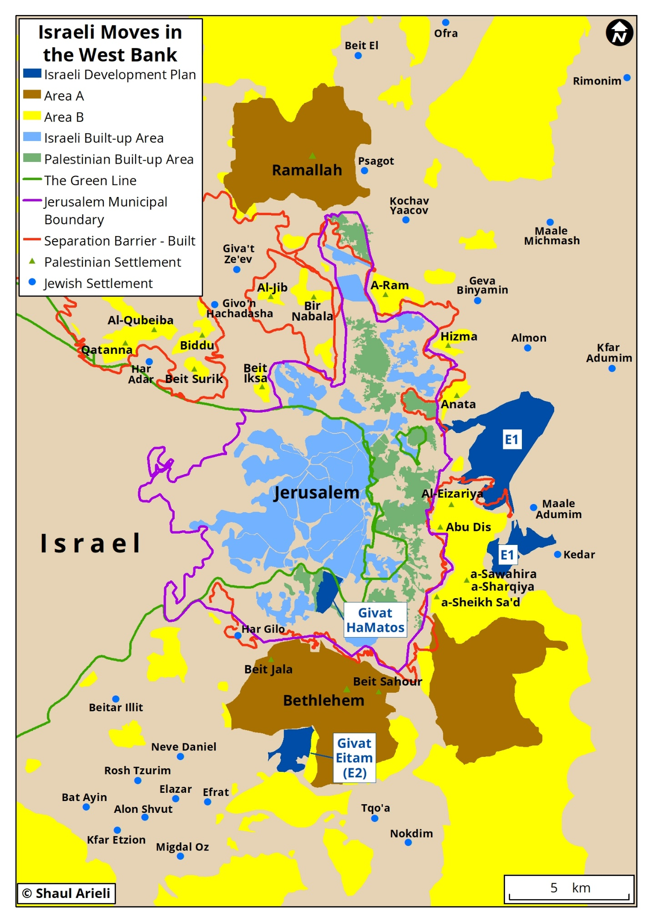

In the second area, legal moves, in recent years the method of de facto annexation has been deepened by promoting direct Knesset legislation on the Occupied Territories, as the Israel Democracy Institute describes in detail, in contrast to past use of military commander orders. In 2017, the government determined that the Ministerial Committee on Legislation would not advance legislation without examining whether it is necessary to apply any proposed law to Israelis living in the territories, and what is the way to do so. For this purpose, a dedicated cluster was established in the Ministry of Justice regarding the application of Israeli law in the territories. In 2016, the Judea and Samaria Subcommittee (Subcommittee of the Foreign Affairs and Defense Committee) was established in the Knesset, dealing with civilian issues concerning the territories and dealing with the advancement of settler affairs.

Thus, in the 20th Knesset, eight laws and legislative amendments were enacted that apply directly to the West Bank. Some of them significantly change the way Israel controls the territories, and directly affect the rights of the Palestinians. Among the laws approved: the Settlement Law (repealed by the High Court in June); an amendment to the Administrative Courts Law, which transferred from the High Court to the Jerusalem Administrative Court the handling of administrative petitions concerning areas in planning and construction, the Freedom of Information Law, entry and exit from the West Bank and even within it, and deportation and supervision orders of the military (the government expects this move will lead to better rulings for the settlers, particularly in the area of ​​planning and construction); Amendment of the Council for Higher Education Law and its application to academic institutions in the settlements, which abolished the separation that existed between the Council for Higher Education in the State of Israel and in Judea and Samaria; an amendment to the Prohibition of Products Discrimination Law and at the same time, the Consumer Protection Law was amended, requiring businesses to indicate whether they do not provide transportation or repair services to a specific area or to certain localities in Israel or in the settlements. Recently, a preliminary reading of the "Regulation of Young Settlement" law was approved, which will "whitewash" the illegal outposts.

In the third area, construction of transportation infrastructure, Transport Minister Miri Regev announced in December the budgeting and implementation of a series of new transportation projects in the West Bank, with a total cost of about 400 million NIS, some of which will be funded by diverting budgets from other projects. The approved projects: the Luban Bypass Road - about NIS 100 million; Modi'in Illit-Lapid Road - NIS 171 million; Qalandiya subsidence - NIS 103 million, and promotion of the planning of the Adam-Hizma road, at a cost of 17 million NIS.

This decision follows the strategic master plan for transportation, which Regev launched in November in the presence of the heads of the Judea and Samaria authorities, and was accompanied by a declaration: "We are not taking our foot off the gas. We are applying de facto sovereignty. "The master plan involves the construction of 167 km of new main roads, in addition to the laying of about 200 km of railway tracks. The plan will cost tens of billions of shekels.

The transportation effort focuses on two areas. The first seeks to connect northern Samaria and southeastern Judea - two areas where the Jewish presence is negligible - to the central settlement system in Judea and Samaria. In the area between Gush Etzion and the Green Line in the southern West Bank, where 20,000 Israelis and 800,000 Palestinians now live. The second aspect is the construction of a railway on the mountain ridge, adjacent to the isolated Israeli settlements, which will connect them to Afula to the north and to Kiryat Gat to the southwest.

This plan, like others launched by Israeli governments as part of creeping annexation, will not overwhelm the Palestinian demographics - a solid majority of 84% of the West Bank population (excluding Jerusalem). It will not erode the spatial control of the Palestinians - private ownership of more than half of the land in Area C. It will not even improve the socio-economic ranking of the settlers - 31% of them, all ultra-Orthodox, live in the two cities in the list of 11 poorest localities in Israel (Cluster 1). An additional 10%, most of them ultra-Orthodox, are in the lower third (clusters 2-3). Only 4%, all secular, most of whom live in settlements adjacent to the Green Line, are ranked in the upper third of the scale (cluster 9). In the absence of Israeli agriculture and industrial areas where Israelis work, 60% of the Israeli labor force living in the West Bank makes its way daily to work within the Green Line, and the expensive transportation system will help them continue to do so. An additional 25%, twice the rate in the Green Line areas, are employed in a subsidized education system with a particularly high per capita expenditure.

These measures will join previous steps of the Israeli governments that will lead to one of two results. One: the continuation of the conflict with all its social and economic consequences for Israeli society, and the rising prices that Israel will be required to pay in terms of evacuation and lost investments on the day it sobers up - alone or after international pressure - and marches to a two-state solution. The second result: a transition from creeping annexation to annexation through law, which will lead Israel to a single state with an Arab majority and an undemocratic regime, which means the end of the Zionist dream envisioned by the founding fathers.

Col. (Res.) Dr. Arieli is a research fellow at the Truman Institute for Peace. He has recently published the Atlas of the Truman Institute for the Jewish-Arab Conflict, in three languages

