Shaul Arieli – The Forum fur Regional Thinking - 11.11.2020
https://www.regthink.org/en/articles/The-Day-Netanyahu-Made-a-Laughingstock-of-Trump
The Day Netanyahu Made a Laughingstock of Trump
Netanyahu’s approval, this month, of the building of, or the advancement of, 5,787 housing units in the settlements, makes a joke of the Trump Plan, and demonstrates the Prime Minister’s unwillingness to keep his political commitments. As usual, he is being held hostage by the sectarian parties who hold the key to his continued survival.
It only took a few months for Prime Minister Netanyahu to show US President Trump and his Special Advisor Kushner clear evidence that he is untrustworthy, and unable to keep political commitments. This month Netanyahu provided an excellent example of this with the approval and advancement of a plan to expand the settlements and Illegal outposts in the West Bank.
In President Trump’s Peace Plan, Kushner and his staff made sure to break up Palestinian territorial continuity by annexing 87% of the settlements, 85% of which are small, isolated settlements, deep in Palestinian territory. Trump was not satisfied with that alone. He adopted the principle, established by Netanyahu and the US Ambassador to Israel, David Friedman, according to which, not one settlement would be evacuated, and therefore, the plan includes 17 settlements that will become “Israeli enclaves within continuous Palestinian territory.” The plan also establishes that the 17,000 Israelis who live in those settlements “will be allowed to stay where they are, unless they choose otherwise, and keep their existing Israeli citizenship. They will be under Israeli civil administration…and the access routes to them will be under Israeli security control.”
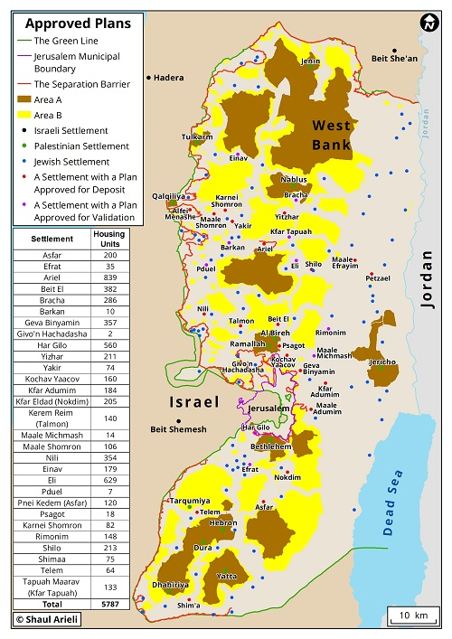
In order to compensate the Palestinians, the following sentence was added to the Plan: “Israel will avoid expanding the Israeli enclaves, mentioned in Paragraph 4, or promote any plan to expand the enclaves in those areas beyond their current borders.”
The Trump Initiative did not made the heads of Yesha and the right-wing messianic-nationalist parties happy, and they published a plan that demands that all the Israeli enclaves be connected to the territory to be annexed to Israel, as well as the dozens of illegal outposts close by, via corridors that would create continuous Israeli territory and would turn the Palestinian “state” into one big sieve.
In the approval, given recently, by Netanyahu and Defense Minister Gantz, to the building of, or advancement of, 5,787 housing units, one can see that the two preferred the “poor” of their own city, the settlers, over the “poretz” Trump. 17% of the approvals were given to settlements that would become Israeli enclaves according to the Trump Plan, in addition to the illegal outposts. So, for instance, is the case in regards to the settlements of Yitzhar and Baracha, which are situated in the heart of the West Bank, near Nablus. They will enjoy 211, and 286 new housing units (respectively). This is also the case for Asfar (200), Pnei Kedem (64) and the isolated Telem (120). The outpost of Tapuach West, which is close to Kfar Tapuch, will remain an enclave, and got approval for 133 housing units.
Regarding the placement of these approvals, it is clear that there is no political agenda behind them in relation to the future of the settlements, if, in the future the Two State Solution is considered, but rather the opposite. The vast majority of the approvals were given to the small, isolated settlements that are beyond the pale of any of Israel’s political offers regarding a permanent border with Palestine.
64% of the housing units are beyond the route of the Israeli offer for the final border during the Annapolis Conference (2008), which allowed Israel to keep its sovereignty over 83% of Israelis living over the green line; 89% of the housing units are east of the already built security barrier, and 68% of them are east of the planned security barrier; 80% of them are even east of the optimal permanent border which was consolidated in in-depth research done by the “Commanders for Israeli Security" Movement, and which would make it possible for 80% of Israelis over the green line to remain under Israeli sovereignty. In the end, all approved housing units are beyond the potential area of Palestinian consent, suggested in the Geneva Initiative, with the exception of two housing units that were approved in New Givon.
Netanyahu has once again been exposed as someone who doesn’t hesitate to bite the hand that feeds him. He did so with President Obama, after he approved security aide to Israel in the unprecedented amount of 38 billion dollars, and so too to President Trump, who gave Israel a lot more than it asked for in his impossible plan.
These approvals once again show that Netanyahu can keep his seat only as long as he fulfills all the requests of the sectarian parties- that they are his political support, and they continue to do whatever they want in terms of the settlements. He cannot take any steps towards any significant process against their interests – from dealing with Corona to the Israeli-Palestinian conflict. In other words, the ability of Netanyahu to rule is like a cheap bright color on painted on disintegrating rust.

