Board of Directors  Peter A. Joseph  Chairman  Charles R. Bronfman  Rabbi Marion Lev Cohen  Susie Gelman  E. Robert Goodkind  Lawrence Gottlieb  Harold R. Handler  Peter Kolevzon  Geoffrey H. Lewis  Robert K. Lifton  James E. Walker, III  Melvyn I. Weiss  Michael D. Young  Advisory Council  In formation  Dan Adler  David Avital  Rabbi Andy Bachman  Neil Barsky  Robert A. Belfer  Jack C. Bendheim  Michael Berenbaum  S. Nicholas Bunzl  Steven M. Cohen  Rabbi David Ellenson  Jeffrey Gural  Alan S. Jaffe  Burt Lehman  Rabbi Robert Levine  Rabbi Joy Levitt  Deborah Lipstadt  Rabbi Roly Matalon  Mike Medavoy  Aaron David Miller  Harriet Mouchly Weiss  Marcia Riklis  David Sable  Julie Sandorf  Rabbi Joel Simonds  Michael W. Sonnenfeldt  Rabbi Michael Strassfeld  Donald Sussman  Rabbi Eric H. Yoffie  Lawrence Zicklin  Staff & Advisors  David A. Halperin  Executive Director  Michael Koplow  Policy Director  Roberta Fahn Schoffman  Israel Director  Martin Raffel  Communications Consultant  Bari Schwartz  Program Associate  Elise Shazar  Jerusalem Representative  Lois H. Silverman  Senior Operations Manager  Dr. Steven L. Spiegel  National Scholar  Nimrod Novik  Israeli Fellow | November 23, 2015  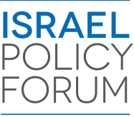  November 29, 2015  Colonel (res.) Shaul Arieli  Dear Shaul,  Thank you again for meeting with our IPF leadership delegation at ECF during their recent visit to Israel. The group benefited greatly from your presentation and analysis on the feasibility of the two-state solution. We received a great deal of positive feedback from participants.  As you well know, IPF’s goal is to bring together community and policy leaders in support of pragmatic US policies that promote a two-state resolution to the Israeli-Palestinian conflict while respecting Israel’s vital security needs. In addition, IPF seeks to cut through the divisiveness and partisanship that has penetrated discussions on these issues in the Jewish community and in Washington. We feel very fortunate to have had the chance to speak with you during our visit to Israel especially in light of and regional and global developments.  We look forward to seeing you again,  Sincerely,  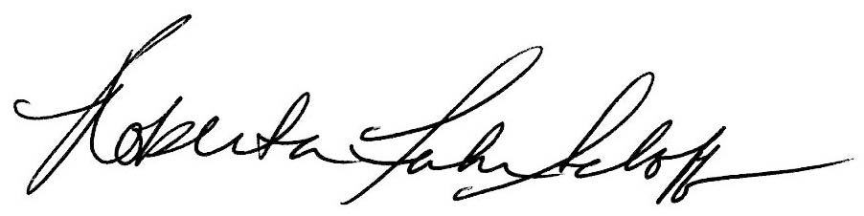  Peter A. Joseph David A. Halperin Roberta Fahn Schoffman  Chairman of the Board Executive Director Israel Representative

